import pandas as pd
import numpy as np
import seaborn as sns
import matplotlib.pyplot as plt
import warnings
warnings.filterwarnings(action="ignore")
from sklearn.model_selection import train_test_split
from sklearn.metrics import accuracy_score, classification_report
from sklearn.ensemble import RandomForestClassifier
from imblearn.over_sampling import SMOTE
from sklearn.metrics import roc_curve, auc
from sklearn import metrics
from sklearn.metrics import confusion_matrix
from sklearn.datasets import make_classification
from sklearn.metrics import accuracy_score, precision_score, recall_score, f1_score
C:\Users\agarw\anaconda3\lib\site-packages\scipy\__init__.py:146: UserWarning: A NumPy version >=1.16.5 and <1.23.0 is required for this version of SciPy (detected version 1.26.2
warnings.warn(f"A NumPy version >={np_minversion} and <{np_maxversion}"
#importing data from the dataset
df = pd.read_csv(r"C:\Users\agarw\OneDrive\Desktop\Dissertation\data.csv")
#checking for bankrupt companies 0 is non-bankrupt and 1 is bankrupt
bankrupt_data = df['Bankrupt?'].value_counts()
bankrupt_data
Bankrupt?
0 6599
1 220
Name: count, dtype: int64
#Distribution representation
plt.figure(figsize = (10,5))
colors = ["#3498db", "#e74c3c"]
ax = sns.countplot(x=df['Bankrupt?'], data=df,palette=colors)
for p in ax.patches:
ax.annotate(f'{p.get_height()}', (p.get_x() + p.get_width() / 2., p.get_height()),
ha='center', va='center', xytext=(0, 10), textcoords='offset points')
# Add labels and title
plt.xlabel('Bankrupt')
plt.ylabel('Count')
plt.title('Distribution of Bankrupt')
# Show the plot
plt.show()
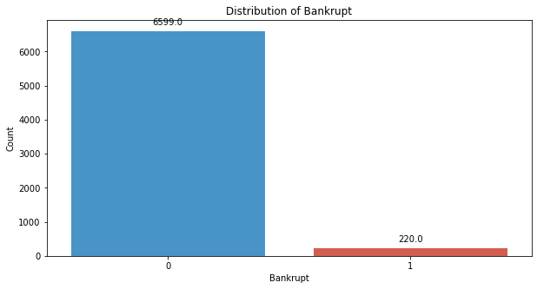
# seperate the Bankrupt label from the dataset
y = df['Bankrupt?']
X = df.drop(['Bankrupt?'], axis = 1)
# divinding our dataset into training dataset
X_train, X_temp, y_train, y_temp = train_test_split(X, y, test_size=0.2, random_state=42)
#Distribution representation
plt.figure(figsize = (10,5))
colors = ["#3498db", "#e74c3c"]
ax = sns.countplot(x=y_train, data=df,palette=colors)
for p in ax.patches:
ax.annotate(f'{p.get_height()}', (p.get_x() + p.get_width() / 2., p.get_height()),
ha='center', va='center', xytext=(0, 10), textcoords='offset points')
# Add labels and title
plt.xlabel('Bankrupt')
plt.ylabel('Count')
plt.title('Distribution of Bankrupt')
# Show the plot
plt.show()
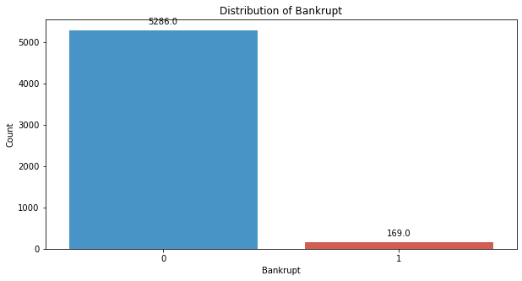
# divinding our dataset into testing and validation
X_val, X_test, y_val, y_test = train_test_split(X_temp, y_temp, test_size=0.5, random_state=42)
clf = RandomForestClassifier(random_state=42)
clf.fit(X_train, y_train)
RandomForestClassifier(random_state=42)
y_pred_val = clf.predict(X_val)
accuracy = accuracy_score(y_val, y_pred_val)
precision = precision_score(y_val, y_pred_val)
recall = recall_score(y_val, y_pred_val)
f1_value = f1_score(y_val, y_pred_val)
print("Accuracy", accuracy)
print("Precision", precision)
print("Recall", recall)
print("F1 Score", f1_value)
Accuracy 0.9721407624633431
Precision 0.6666666666666666
Recall 0.1
F1 Score 0.1739130434782609
conf_matrix = confusion_matrix(y_val, y_pred_val)
print("Confusion Matrix")
print(conf_matrix)
Confusion Matrix
[[661 1]
[ 18 2]]
class_report = classification_report(y_val, y_pred_val)
print(class_report)
precision recall f1-score support
0 0.97 1.00 0.99 662
1 0.67 0.10 0.17 20
accuracy 0.97 682
macro avg 0.82 0.55 0.58 682
weighted avg 0.96 0.97 0.96 682
y_pred_testing = clf.predict(X_test)
accuracy = accuracy_score(y_test, y_pred_testing)
precision = precision_score(y_test, y_pred_testing)
recall = recall_score(y_test, y_pred_testing)
f1_value = f1_score(y_test, y_pred_testing)
print("Accuracy", accuracy)
print("Precision", precision)
print("Recall", recall)
print("F1 Score", f1_value)
Accuracy 0.9633431085043989
Precision 0.875
Recall 0.22580645161290322
F1 Score 0.358974358974359
conf_matrix = confusion_matrix(y_test, y_pred_testing)
print("Confusion Matrix")
print(conf_matrix)
Confusion Matrix
[[650 1]
[ 24 7]]
class_report = classification_report(y_val, y_pred_testing)
print(class_report)
precision recall f1-score support
0 0.97 0.99 0.98 662
1 0.00 0.00 0.00 20
accuracy 0.96 682
macro avg 0.49 0.49 0.49 682
weighted avg 0.94 0.96 0.95 682
# Compute ROC curve and ROC area for each class
fpr_val, tpr_val, _ = roc_curve(y_val, y_pred_val)
roc_auc_val = auc(fpr_val, tpr_val)
fpr_test, tpr_test, _ = roc_curve(y_test, y_pred_testing)
roc_auc_test = auc(fpr_test, tpr_test)
# Plot ROC curve
plt.figure(figsize=(8, 8))
plt.plot(fpr_val, tpr_val, color='darkorange', lw=2, label=f'Validation ROC curve (area = {roc_auc_val:.2f})')
plt.plot(fpr_test, tpr_test, color='green', lw=2, label=f'Test ROC curve (area = {roc_auc_test:.2f})')
plt.plot([0, 1], [0, 1], color='navy', lw=2, linestyle='--')
plt.xlim([0.0, 1.0])
plt.ylim([0.0, 1.05])
plt.xlabel('False Positive Rate')
plt.ylabel('True Positive Rate')
plt.title('Receiver Operating Characteristic (ROC) Curve')
plt.legend(loc="lower right")
plt.show()
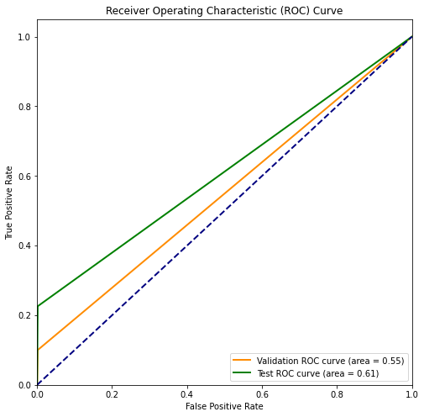
# divinding our dataset into training dataset
X_train_smote, X_temp_smote, y_train_smote, y_temp_smote = train_test_split(X, y, test_size=0.2, random_state=42)
X_val_smote, X_test_smote, y_val_smote, y_test_smote = train_test_split(X_temp_smote, y_temp_smote, test_size=0.5, random_state=42)
smote = SMOTE(sampling_strategy=1,random_state=42)
X_resampled_smote, y_resampled_smote = smote.fit_resample(X_train_smote, y_train_smote)
#Distribution representation
plt.figure(figsize = (10,5))
colors = ["#3498db", "#e74c3c"]
ax = sns.countplot(x=y_resampled_smote, data=df,palette=colors)
for p in ax.patches:
ax.annotate(f'{p.get_height()}', (p.get_x() + p.get_width() / 2., p.get_height()),
ha='center', va='center', xytext=(0, 10), textcoords='offset points')
# Add labels and title
plt.xlabel('Bankrupt')
plt.ylabel('Count')
plt.title('Distribution of Bankrupt')
# Show the plot
plt.show()
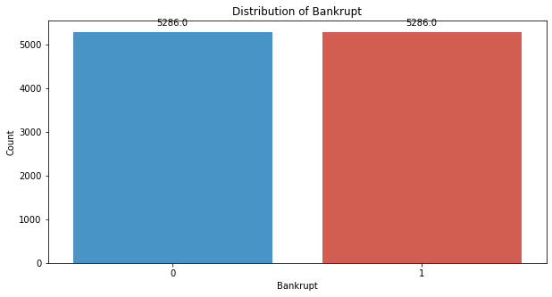
clf_smote = RandomForestClassifier(random_state=42)
clf.fit(X_resampled_smote, y_resampled_smote)
RandomForestClassifier(random_state=42)
y_pred_val_smote = clf.predict(X_val_smote)
accuracy = accuracy_score(y_val_smote, y_pred_val_smote)
precision = precision_score(y_val_smote, y_pred_val_smote)
recall = recall_score(y_val_smote, y_pred_val_smote)
f1_value = f1_score(y_val_smote, y_pred_val_smote)
print("Accuracy", accuracy)
print("Precision", precision)
print("Recall", recall)
print("F1 Score", f1_value)
Accuracy 0.9589442815249267
Precision 0.375
Recall 0.6
F1 Score 0.4615384615384615
conf_matrix = confusion_matrix(y_val_smote, y_pred_val_smote)
print("Confusion Matrix")
print(conf_matrix)
Confusion Matrix
[[642 20]
[ 8 12]]
class_report = classification_report(y_val_smote, y_pred_val_smote)
print(class_report)
precision recall f1-score support
0 0.99 0.97 0.98 662
1 0.38 0.60 0.46 20
accuracy 0.96 682
macro avg 0.68 0.78 0.72 682
weighted avg 0.97 0.96 0.96 682
y_pred_testing_smote = clf.predict(X_test_smote)
accuracy = accuracy_score(y_test_smote, y_pred_testing_smote)
precision = precision_score(y_test_smote, y_pred_testing_smote)
recall = recall_score(y_test_smote, y_pred_testing_smote)
f1_value = f1_score(y_test_smote, y_pred_testing_smote)
print("Accuracy", accuracy)
print("Precision", precision)
print("Recall", recall)
print("F1 Score", f1_value)
Accuracy 0.9472140762463344
Precision 0.43243243243243246
Recall 0.5161290322580645
F1 Score 0.47058823529411764
conf_matrix = confusion_matrix(y_test_smote, y_pred_testing_smote)
print("Confusion Matrix")
print(conf_matrix)
Confusion Matrix
[[630 21]
[ 15 16]]
class_report = classification_report(y_test_smote, y_pred_testing_smote)
print(class_report)
precision recall f1-score support
0 0.98 0.97 0.97 651
1 0.43 0.52 0.47 31
accuracy 0.95 682
macro avg 0.70 0.74 0.72 682
weighted avg 0.95 0.95 0.95 682
# Compute ROC curve and ROC area for each class
fpr_val, tpr_val, _ = roc_curve(y_val_smote, y_pred_val_smote)
roc_auc_val = auc(fpr_val, tpr_val)
fpr_test, tpr_test, _ = roc_curve(y_test_smote, y_pred_testing_smote)
roc_auc_test = auc(fpr_test, tpr_test)
# Plot ROC curve
plt.figure(figsize=(8, 8))
plt.plot(fpr_val, tpr_val, color='darkorange', lw=2, label=f'Validation ROC curve (area = {roc_auc_val:.2f})')
plt.plot(fpr_test, tpr_test, color='green', lw=2, label=f'Test ROC curve (area = {roc_auc_test:.2f})')
plt.plot([0, 1], [0, 1], color='navy', lw=2, linestyle='--')
plt.xlim([0.0, 1.0])
plt.ylim([0.0, 1.05])
plt.xlabel('False Positive Rate')
plt.ylabel('True Positive Rate')
plt.title('Receiver Operating Characteristic (ROC) Curve')
plt.legend(loc="lower right")
plt.show()
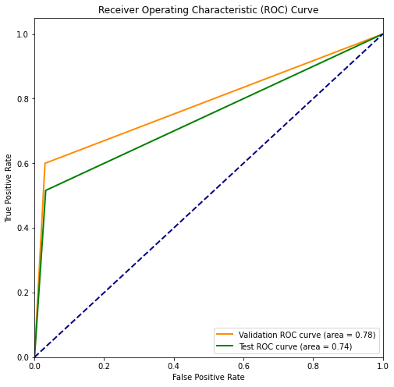
# divinding our dataset into training dataset
X_train_smote, X_temp_smote, y_train_smote, y_temp_smote = train_test_split(X, y, test_size=0.2, random_state=42)
X_val_smote, X_test_smote, y_val_smote, y_test_smote = train_test_split(X_temp_smote, y_temp_smote, test_size=0.5, random_state=42)
smote = SMOTE(sampling_strategy=0.5,random_state=42)
X_resampled_smote, y_resampled_smote = smote.fit_resample(X_train_smote, y_train_smote)
#Distribution representation
plt.figure(figsize = (10,5))
colors = ["#3498db", "#e74c3c"]
ax = sns.countplot(x=y_resampled_smote, data=df,palette=colors)
for p in ax.patches:
ax.annotate(f'{p.get_height()}', (p.get_x() + p.get_width() / 2., p.get_height()),
ha='center', va='center', xytext=(0, 10), textcoords='offset points')
# Add labels and title
plt.xlabel('Bankrupt')
plt.ylabel('Count')
plt.title('Distribution of Bankrupt')
# Show the plot
plt.show()
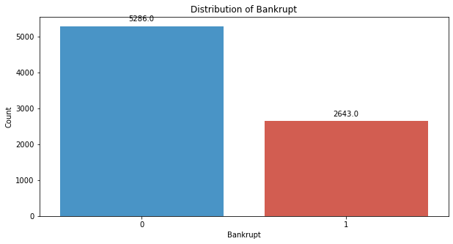
clf_smote = RandomForestClassifier(random_state=42)
clf.fit(X_resampled_smote, y_resampled_smote)
RandomForestClassifier(random_state=42)
y_pred_val_smote = clf.predict(X_val_smote)
accuracy = accuracy_score(y_val_smote, y_pred_val_smote)
precision = precision_score(y_val_smote, y_pred_val_smote)
recall = recall_score(y_val_smote, y_pred_val_smote)
f1_value = f1_score(y_val_smote, y_pred_val_smote)
print("Accuracy", accuracy)
print("Precision", precision)
print("Recall", recall)
print("F1 Score", f1_value)
Accuracy 0.9633431085043989
Precision 0.4074074074074074
Recall 0.55
F1 Score 0.46808510638297873
conf_matrix = confusion_matrix(y_val_smote, y_pred_val_smote)
print("Confusion Matrix")
print(conf_matrix)
Confusion Matrix
[[646 16]
[ 9 11]]
class_report = classification_report(y_val_smote, y_pred_val_smote)
print(class_report)
precision recall f1-score support
0 0.99 0.98 0.98 662
1 0.41 0.55 0.47 20
accuracy 0.96 682
macro avg 0.70 0.76 0.72 682
weighted avg 0.97 0.96 0.97 682
y_pred_testing_smote = clf.predict(X_test_smote)
accuracy = accuracy_score(y_test_smote, y_pred_testing_smote)
precision = precision_score(y_test_smote, y_pred_testing_smote)
recall = recall_score(y_test_smote, y_pred_testing_smote)
f1_value = f1_score(y_test_smote, y_pred_testing_smote)
print("Accuracy", accuracy)
print("Precision", precision)
print("Recall", recall)
print("F1 Score", f1_value)
Accuracy 0.9530791788856305
Precision 0.48484848484848486
Recall 0.5161290322580645
F1 Score 0.5
conf_matrix = confusion_matrix(y_test_smote, y_pred_testing_smote)
print("Confusion Matrix")
print(conf_matrix)
Confusion Matrix
[[634 17]
[ 15 16]]
class_report = classification_report(y_test_smote, y_pred_testing_smote)
print(class_report)
precision recall f1-score support
0 0.98 0.97 0.98 651
1 0.48 0.52 0.50 31
accuracy 0.95 682
macro avg 0.73 0.75 0.74 682
weighted avg 0.95 0.95 0.95 682
# Compute ROC curve and ROC area for each class
fpr_val, tpr_val, _ = roc_curve(y_val_smote, y_pred_val_smote)
roc_auc_val = auc(fpr_val, tpr_val)
fpr_test, tpr_test, _ = roc_curve(y_test_smote, y_pred_testing_smote)
roc_auc_test = auc(fpr_test, tpr_test)
# Plot ROC curve
plt.figure(figsize=(8, 8))
plt.plot(fpr_val, tpr_val, color='darkorange', lw=2, label=f'Validation ROC curve (area = {roc_auc_val:.2f})')
plt.plot(fpr_test, tpr_test, color='green', lw=2, label=f'Test ROC curve (area = {roc_auc_test:.2f})')
plt.plot([0, 1], [0, 1], color='navy', lw=2, linestyle='--')
plt.xlim([0.0, 1.0])
plt.ylim([0.0, 1.05])
plt.xlabel('False Positive Rate')
plt.ylabel('True Positive Rate')
plt.title('Receiver Operating Characteristic (ROC) Curve')
plt.legend(loc="lower right")
plt.show()
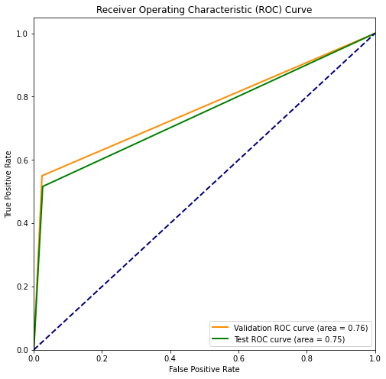
# divinding our dataset into training dataset
X_train_smote, X_temp_smote, y_train_smote, y_temp_smote = train_test_split(X, y, test_size=0.2, random_state=42)
X_val_smote, X_test_smote, y_val_smote, y_test_smote = train_test_split(X_temp_smote, y_temp_smote, test_size=0.5, random_state=42)
smote = SMOTE(sampling_strategy=0.25,random_state=42)
X_resampled_smote, y_resampled_smote = smote.fit_resample(X_train_smote, y_train_smote)
#Distribution representation
plt.figure(figsize = (10,5))
colors = ["#3498db", "#e74c3c"]
ax = sns.countplot(x=y_resampled_smote, data=df,palette=colors)
for p in ax.patches:
ax.annotate(f'{p.get_height()}', (p.get_x() + p.get_width() / 2., p.get_height()),
ha='center', va='center', xytext=(0, 10), textcoords='offset points')
# Add labels and title
plt.xlabel('Bankrupt')
plt.ylabel('Count')
plt.title('Distribution of Bankrupt')
# Show the plot
plt.show()
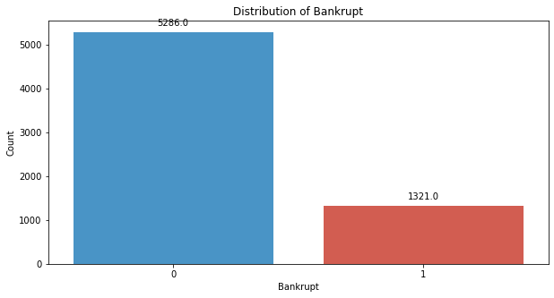
clf_smote = RandomForestClassifier(random_state=42)
clf.fit(X_resampled_smote, y_resampled_smote)
RandomForestClassifier(random_state=42)
y_pred_val_smote = clf.predict(X_val_smote)
accuracy = accuracy_score(y_val_smote, y_pred_val_smote)
precision = precision_score(y_val_smote, y_pred_val_smote)
recall = recall_score(y_val_smote, y_pred_val_smote)
f1_value = f1_score(y_val_smote, y_pred_val_smote)
print("Accuracy", accuracy)
print("Precision", precision)
print("Recall", recall)
print("F1 Score", f1_value)
Accuracy 0.9750733137829912
Precision 0.5789473684210527
Recall 0.55
F1 Score 0.5641025641025641
conf_matrix = confusion_matrix(y_test_smote, y_pred_testing_smote)
print("Confusion Matrix")
print(conf_matrix)
Confusion Matrix
[[634 17]
[ 15 16]]
class_report = classification_report(y_val_smote, y_pred_val_smote)
print(class_report)
precision recall f1-score support
0 0.99 0.99 0.99 662
1 0.58 0.55 0.56 20
accuracy 0.98 682
macro avg 0.78 0.77 0.78 682
weighted avg 0.97 0.98 0.97 682
y_pred_testing_smote = clf.predict(X_test_smote)
accuracy = accuracy_score(y_test_smote, y_pred_testing_smote)
precision = precision_score(y_test_smote, y_pred_testing_smote)
recall = recall_score(y_test_smote, y_pred_testing_smote)
f1_value = f1_score(y_test_smote, y_pred_testing_smote)
print("Accuracy", accuracy)
print("Precision", precision)
print("Recall", recall)
print("F1 Score", f1_value)
Accuracy 0.9545454545454546
Precision 0.5
Recall 0.3870967741935484
F1 Score 0.43636363636363634
conf_matrix = confusion_matrix(y_test_smote, y_pred_testing_smote)
print("Confusion Matrix")
print(conf_matrix)
Confusion Matrix
[[639 12]
[ 19 12]]
class_report = classification_report(y_test_smote, y_pred_testing_smote)
print(class_report)
precision recall f1-score support
0 0.97 0.98 0.98 651
1 0.50 0.39 0.44 31
accuracy 0.95 682
macro avg 0.74 0.68 0.71 682
weighted avg 0.95 0.95 0.95 682
# Compute ROC curve and ROC area for each class
fpr_val, tpr_val, _ = roc_curve(y_val_smote, y_pred_val_smote)
roc_auc_val = auc(fpr_val, tpr_val)
fpr_test, tpr_test, _ = roc_curve(y_test_smote, y_pred_testing_smote)
roc_auc_test = auc(fpr_test, tpr_test)
# Plot ROC curve
plt.figure(figsize=(8, 8))
plt.plot(fpr_val, tpr_val, color='darkorange', lw=2, label=f'Validation ROC curve (area = {roc_auc_val:.2f})')
plt.plot(fpr_test, tpr_test, color='green', lw=2, label=f'Test ROC curve (area = {roc_auc_test:.2f})')
plt.plot([0, 1], [0, 1], color='navy', lw=2, linestyle='--')
plt.xlim([0.0, 1.0])
plt.ylim([0.0, 1.05])
plt.xlabel('False Positive Rate')
plt.ylabel('True Positive Rate')
plt.title('Receiver Operating Characteristic (ROC) Curve')
plt.legend(loc="lower right")
plt.show()
